WEEK: May 26th- June 2nd (K-4 Calendar)

Tuesday  May 26th | AM ACTIVITY: Sink or Swim  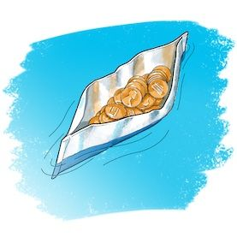  INSTRUCTIONS:  Challenge: Using tinfoil create a device or vehicle that floats  Materials: tinfoil, small tub of water, playdough, tape  Think of things that float (rafts, life vests, pool toys). Can you design something similar?  - What items could you use to replace the tinfoil? Why?  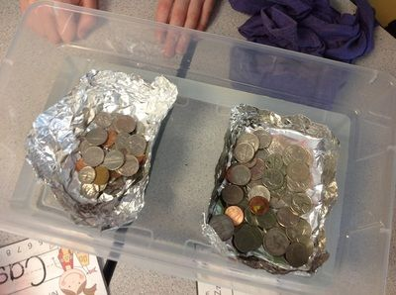  - Can your device hold weight? Try adding coins or marbles. Change your design where needed to help your device hold more weight. | PM ACTIVITY: Catching Rays  INSTRUCTIONS:  Challenge: Make a device that can focus the sun in one spot. (Be careful not to focus it on people or animals)  Materials: card stock or a thicker piece of paper, glue, paper clips, aluminum foil  - The foil bounces the light around. Can you twist or roll the paper to make the sunlight focus on a smaller spot?  - How can your creation be used to solve a problem? Can it heat things? Light up a dark area? Talk with your child about what different things your creation can be used for.  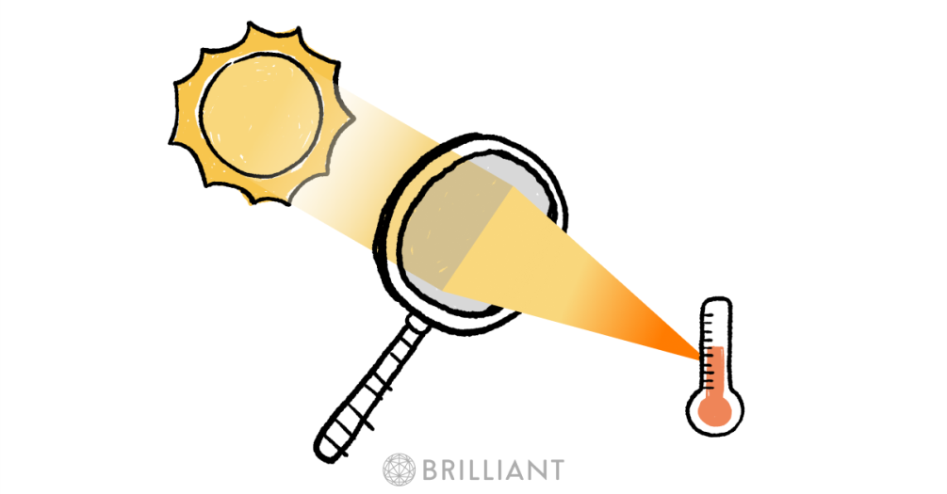

WEEK: May 26th- June 2nd (K-4 Calendar)

Wednesday May 27th | AM ACTIVITY: Digest this!  INSTRUCTIONS:  Challenge: Figure out the best way to “digest” a cracker (break it down)  Materials: crackers, re-sealable plastic bag, water, vinegar, clear soda  - Your teeth are the first part of the digestive process. How can you do the same thing to your cracker?  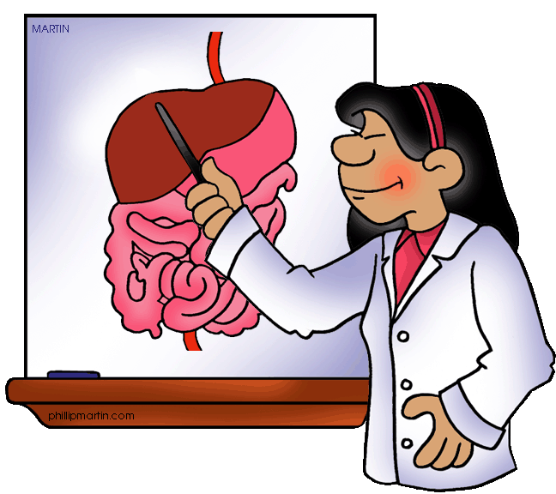  - Write the steps you took to “digest” the cracker. How are they the same as the digestive process? How are they different?  - Your teeth and stomach act like tools to crush and break food. What tool(s) did you use for this?  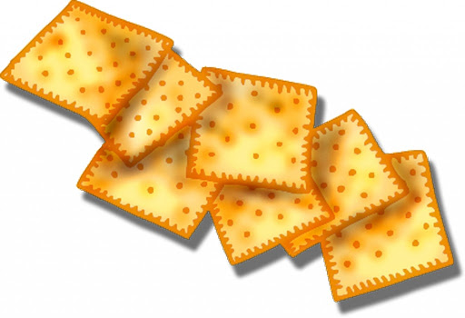 | PM ACTIVITY: Climbing water  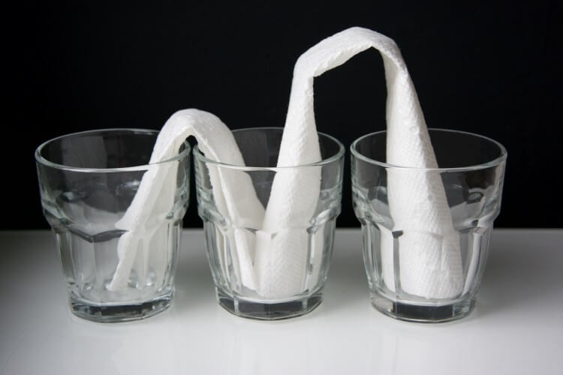  INSTRUCTIONS:  Challenge: move water from one cup to another cup without touching the cups or pouring the water out  Materials: cups, water, paper towel, food colouring or some different coloured liquid  - Think about what a paper towel does to water. How can you place the paper towel to help the water move?  - Try different cups or even different types of paper towels. How do they affect the way the water moves?  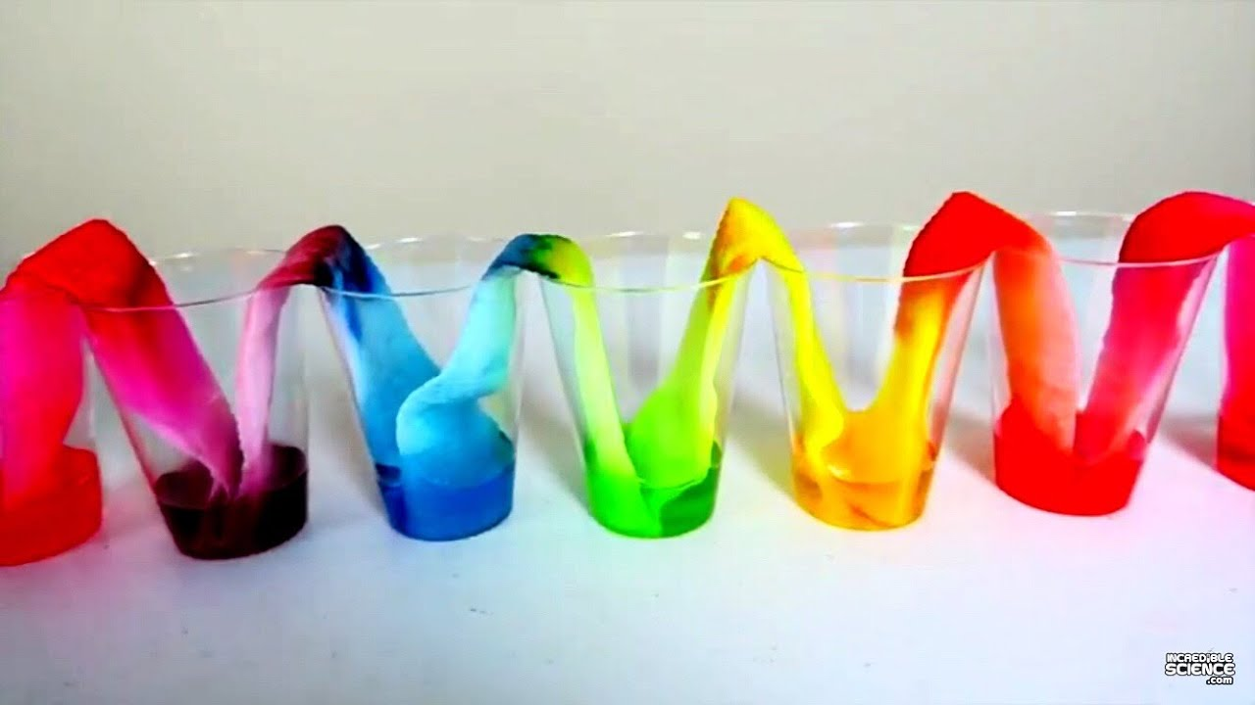  - How could you use more cups and food colouring to make a rainbow? What colours mix together to make other colours?

WEEK: May 26th- June 2nd (K-4 Calendar)

Thursday May 28th | AM ACTIVITY: Bridging the gap  INSTRUCTIONS:  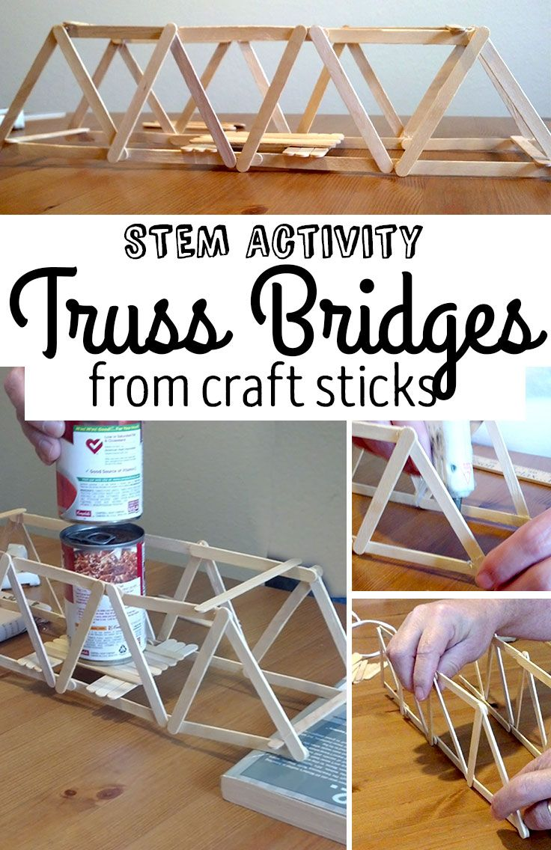  Challenge: build a bridge that is at least 12 inches long. It should be able to support at least 10 coins of the same denomination (dimes, nickels) in the middle  Materials: yarn or string, craft sticks or pieces of similar consistency, cardboard, tape, coins of your choice  Bridges need support underneath or from above. Before you get started look at pictures of real bridges to see how they are built.  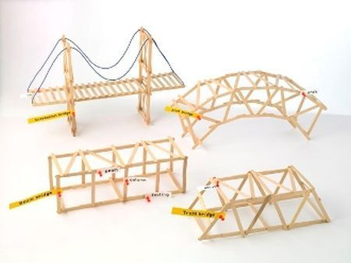 | PM ACTIVITY: Digging dinos  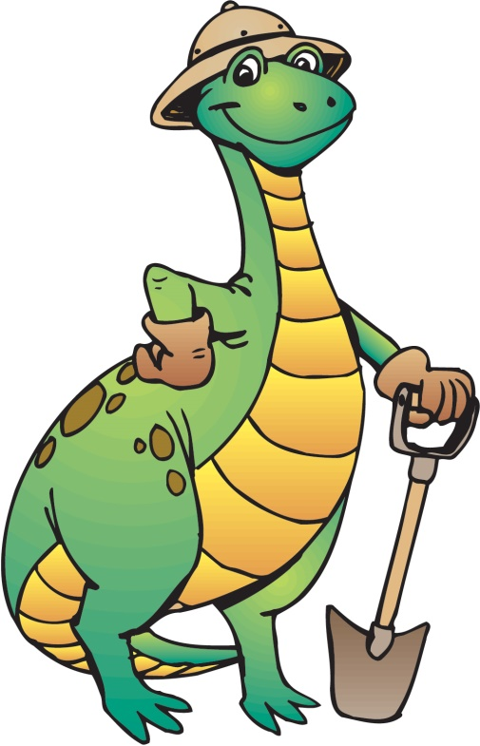  INSTRUCTIONS:  Challenge: dig out the “fossils” (chocolate chips) from the “dirt” (cookie) without breaking them  Materials: chocolate chip cookies, paper towel or plate, tooth pick, paintbrush or toothbrush, cotton swab  - Using the tools dig around the cookie to try and remove the chocolate chips without breaking the cookie. The toothpick can be used for the digging and the paintbrush/toothbrush can be used to brush away the crumbs  - How many “fossils” did you find? What size was the original cookie? About how big is each “fossil”?  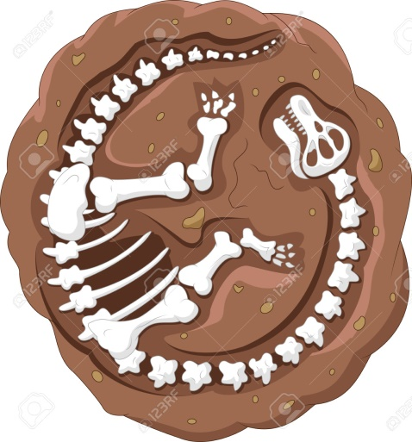
WEEK: May 26th- June 2nd (K-4 Calendar)

Friday May 29th | AM ACTIVITY: Stargazing  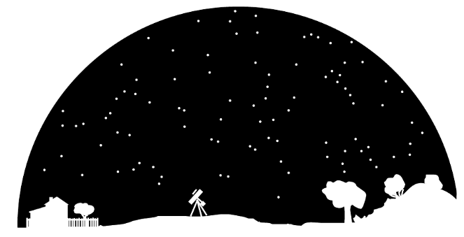  INSTRUCTIONS:  Challenge: Make a night-light that projects stars and other night sky objects, like the moon  Materials: Black or dark paper or fabric, aluminum foil, wax paper, cardboard, toothpick or scissors, flashlight or electric tea light  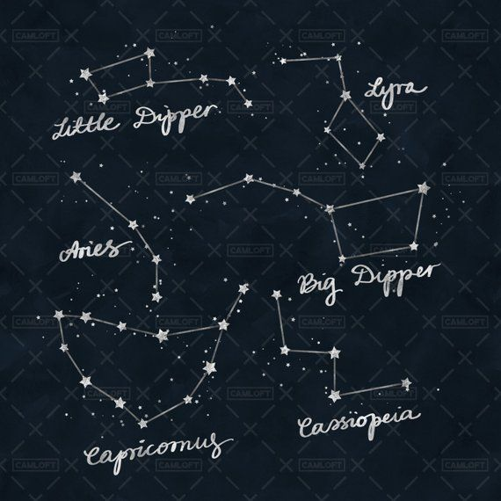  - Using the materials needed poke holes to create a night sky all over the paper or fabric that you are using  - You can use the aluminum foil or wax paper to create different concentrations of light (making the light shining through brighter or dimmer)  - Test out your night skyscape in a dark room or before bed  - There are many different objects that we can observe in the night sky. Which objects does your night-light sky include? Why did you decide to include those objects in your night-sky? | PM ACTIVITY: Growing, growing, gone  INSTRUCTIONS:  Challenge: Grow a plant without soil  Materials: water, paper towel, sponges (optional), clear plastic cup, zip lock bag, clear glass or jar, quick sprouting seeds (e.g. grass, beans)  - Soak seeds in water overnight in a cup, or an a plate  - Take seed and wrap them or place them on a damp paper towel and place the paper towel in your container of choice  - Place the container in a space that ensures that it will receive air and sunlight  - Make sure the paper towel remains damp but not too wet  - Draw your observations every couple of days to document what is happening with your seeds.  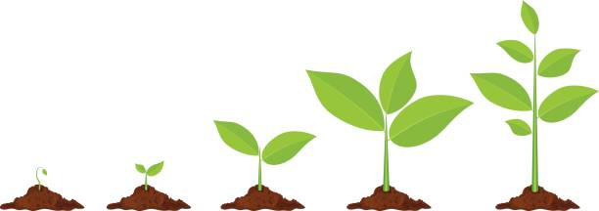

WEEK: May 26th- June 2nd (K-4 Calendar)
Monday June 2nd | AM ACTIVITY: Estimation Game  INSTRUCTIONS:  What You Need: Deck of cards (with the face cards removed) Two or more players A pencil for each player Paper  What You Do:  - Give each player a piece of scrap paper for working out the equations.  - Give each player another piece of paper to record their scores. On this piece of paper have the players create two score columns; one for guesses, another for estimates.  - Have your child shuffle the deck of cards. Aces have a value of 1 for the purpose of this game.  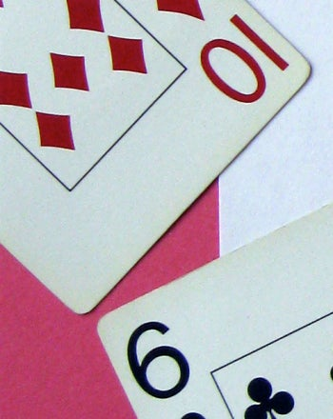  - Next, have your child decide who the dealer will be.  - The dealer must then deal a card to themselves and the other player(s) face down.  - Both your child and the other player(s) should guess the value of the card they have been dealt.  - Have your child and the other player(s) count to three. On three, they should all flip their cards over.  - Player(s) should then calculate the difference between what they guessed and the value of the actual card and record the difference in the guess column of their scorecards.  - Discard that round of cards.  - The dealer should then deal a new round of cards.  - After 5 rounds have them add up their guess scores and calculate the difference between their estimates.  - Record the difference in the estimate column.  - Continue until the deck has run out.  - At the end, have the player(s) add up all of their scores from both of the columns. The player with the lowest score wins! | PM ACTIVITY: Petanque  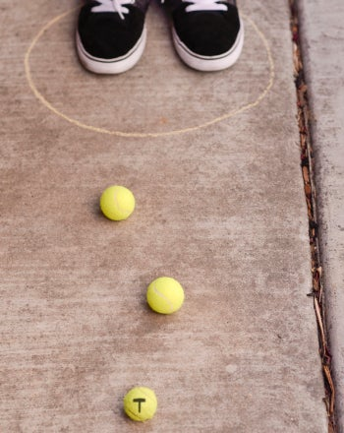  INSTRUCTIONS:  What you need: 6 to 16 tennis balls or any type of ball you are ok with writing on, 2-8 players, Chalk, Permanent marker  What You Do:  - Explain to your child that petanque is a French ball game (somewhat similar to horseshoes)  - Make 2 (at least two people should play) teams with the same number of people (up to 4) per team. Teams of 1 or 2 players get 3 balls per player; teams with 3 or 4 players get 2 balls per person. Write “1” with the marker on Team 1 balls, and “2” on the others.  - Find a semi-hard surface (compact soil, concrete, or a solid grassy yard) so balls can roll. The space should be 12 feet by 40 feet or larger.  - Use chalk to draw a circle about 20 inches in diameter any place on the play area.  - Have Team 1’s first player stand in the circle and throw the ball, making sure their feet stay inside the circle. They should aim for the ball to land 18 to 30 feet away. Write “T” for “Target” on this ball.  - Other Team 1 players (if any) now take turns each throwing a ball while keeping their feet inside the circle. Players should each try to get their ball as close to the target ball as possible.  - Next, each Team 2 player goes in the circle to throw one ball, aiming to get even closer to the target. They can try to knock away any of Team 1’s balls so that theirs is closer to the target.  - Whichever team does not have the leading ball goes next, each throwing a ball until they are leading. Then the next team takes turns.  - When a team has no balls left, the other team throws their remaining balls.  - After all balls are thrown, the leading team scores 1 point for each of its balls which are closer to the target than any balls from the other team.  - A new circle is drawn in the old target area, and the game starts again. Play usually continues until one team reaches 13 points total—may the best team win!

