ELA Literary Focus 30/40SS Campbell’s Class
April21-28 work and lesson package
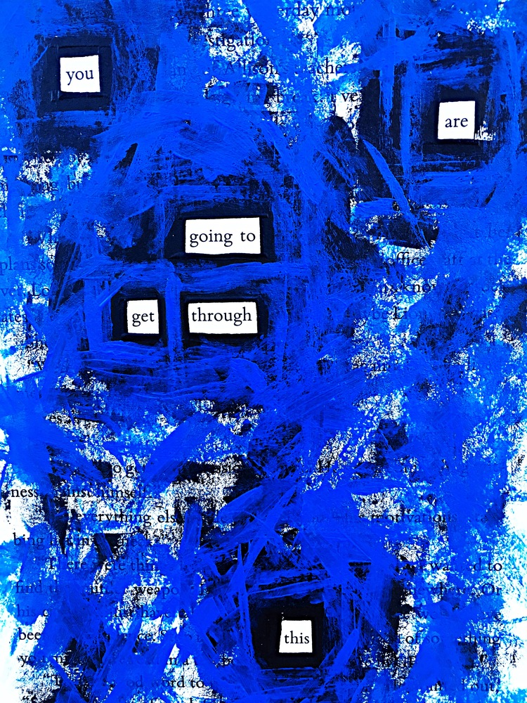
https://www.google.com/search?q=black+out+poetry&tbm=isch&ved=2ahUKEwiRjvWBlvDoAhWJn60KHcirBNkQ2-cCegQIABAA&oq=black+out+poetry&gs_lcp=CgNpbWcQAzICCAAyAggAMgIIADICCAAyAggAMgIIADICCAAyAggAMgIIADoECAAQQzoFCAAQgwE6BwgAEIMBEENQ26s2WL3YNmCp2jZoBHAAeACAAaoBiAGzDZIBBDE5LjGYAQCgAQGqAQtnd3Mtd2l6LWltZ7ABAA&sclient=img&ei=YACaXpHeEYm_tgXI15LIDQ&bih=637&biw=1440&safe=strict#imgrc=tenHxYqGFAvtoM SOURCE
“Black out Poetry”Creating Poetry Through Subtraction 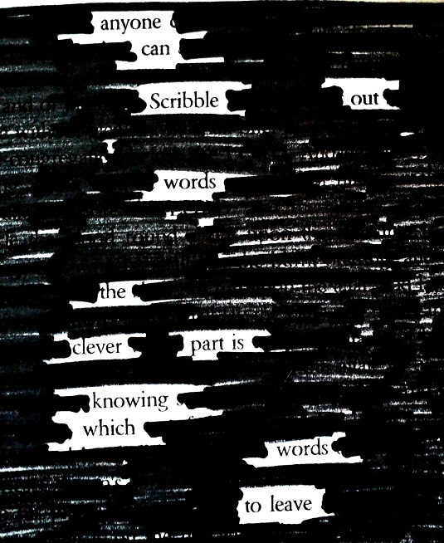
https://www.bing.com/images/search?view=detailV2&id=8CFD098B9D5860345AD9DFAA353E1E5E24DA3C4E&thid=OIP._SRFQZtQU5lFvfX0T-wYcwHaJD&mediaurl=http%3A%2F%2F1.bp.blogspot.com%2F-Fy9XAgnvrbM%2FU4nEnrUCJCI%2FAAAAAAAAEgo%2FrXPIB0LxKQU%2Fs1600%2FNewspaper-Blackout-Words-Poetry-1.jpg&exph=764&expw=625&q=black+out+poetry&selectedindex=21&ajaxhist=0&vt=0&eim=6 Source
Dear ELA 30S/40S dedicated and cherished students, PLEASE READ THROUGH REFLECT AND ENJOY THE EXAMPLES ON THE COVER THIS PAGE AND THE NEXT SEVERAL PAGES . THIS IS YOUR MAIN TASK THIS WEEK IS TO CREATE TWO BLACK OUT OR COLOUR OUT POEMS (THREE IF YOU APPRECIATE THE PROCESS ).. NOTE YOU WILL need to select and create your poems for the provided texts (in this weeks work package) Lightly use a pencil to shade out first, or separate out, then use the sharpie or colour once you are content with your found poem.
As well, this week please ensure that you aspiring (and setting fairly firm personal academic goals) to complete and hand in The Evolution of Alice assignments this week via bus pick up on April 28th, or anytime prior via email or taking a picture of your work and uploading it into chat Office 365 teams for me. Journey on . This is an emotionally challenging time . You are power girls and caregivers. Be good to yourself . Be sure to get fresh air and soak up this long awaited sun and try and get lost in some literarture and creativity. It is good distraction and wellness promoting.
Talk soon. Read out anytime ccampbell@sunrisesd.ca
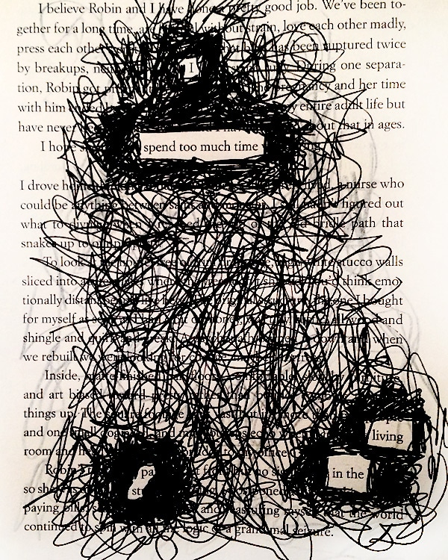 Be in the momment and move forward channelling your optimism ELA Lit Girls ! Miss Campbell
SOURCEhttps://www.google.com/search?q=black+out+poetry&tbm=isch&ved=2ahUKEwiRjvWBlvDoAhWJn60KHcirBNkQ2-cCegQIABAA&oq=black+out+poetry&gs_lcp=CgNpbWcQAzICCAAyAggAMgIIADICCAAyAggAMgIIADICCAAyAggAMgIIADoECAAQQzoFCAAQgwE6BwgAEIMBEENQ26s2WL3YNmCp2jZoBHAAeACAAaoBiAGzDZIBBDE5LjGYAQCgAQGqAQtnd3Mtd2l6LWltZ7ABAA&sclient=img&ei=YACaXpHeEYm_tgXI15LIDQ&bih=637&biw=1440&safe=strict#imgrc=jeDDM_P1gZM9tM
Source: 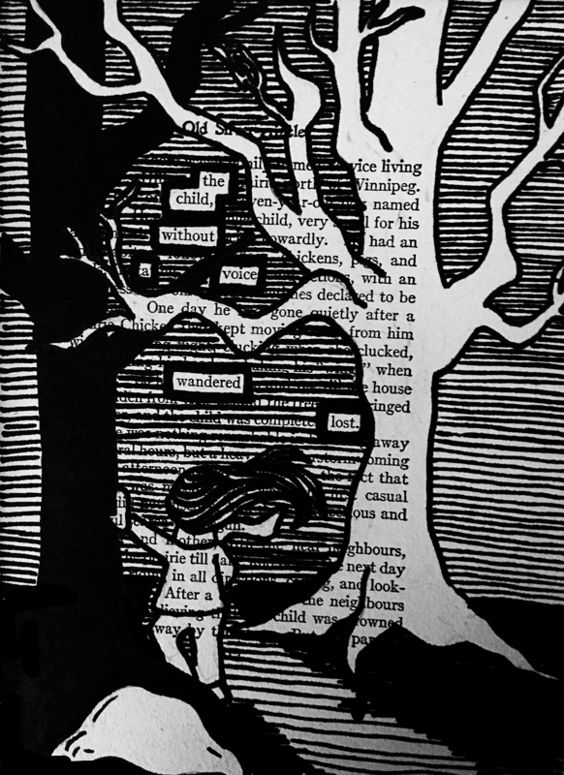
SourceLhttps://www.lynnereeder.com/blackout-poetry.html
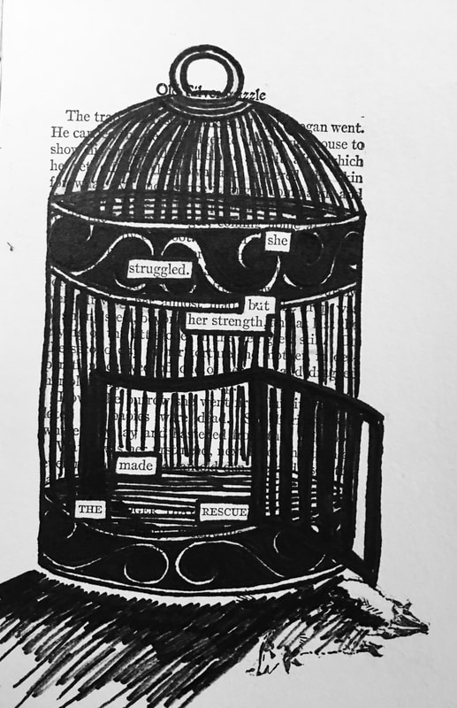 https://www.lynnereeder.com/blackout-poetry.html Source

SOURCEhttps://www.lynnereeder.com/blackout-poetry.html 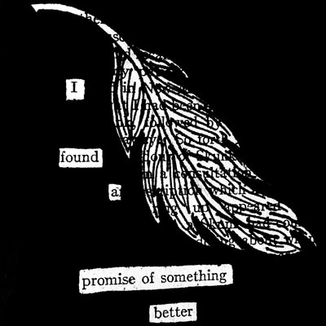

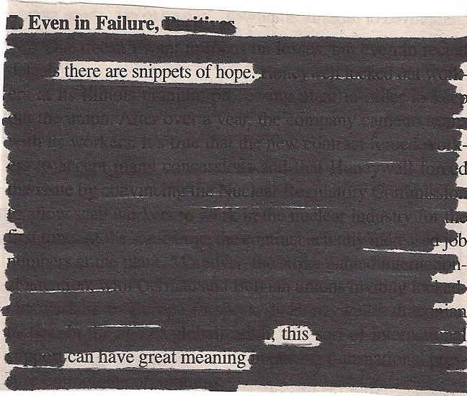https://mymodernmet.com/austin-kleon-newspaper-blackout-poetry/

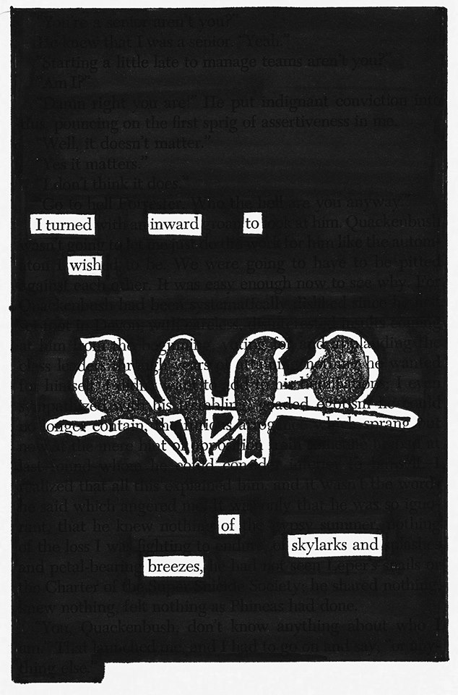http://visitfloydva.com/wp-content/uploads/2018/03/blackoutpoet.jpg Source

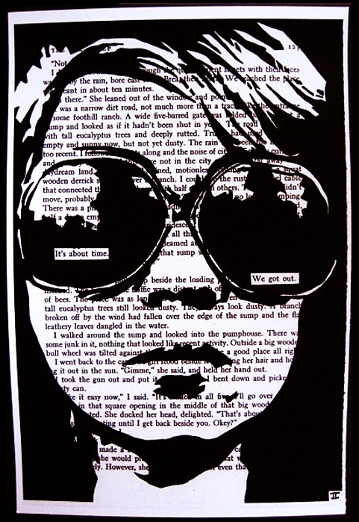
http://sanderlinclassroom.weebly.com/uploads/4/7/1/7/47177579/4353674_orig.jpg SOURCE

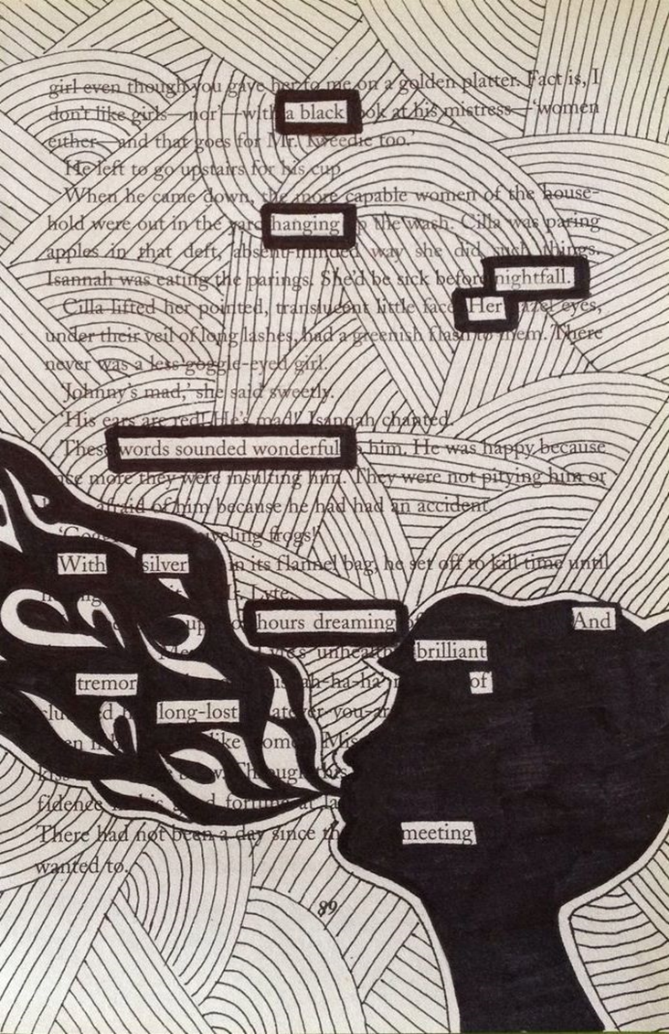
https://i.pinimg.com/originals/2b/09/7d/2b097de0d0c50efc4dac0a48bf6a3c40.jpg

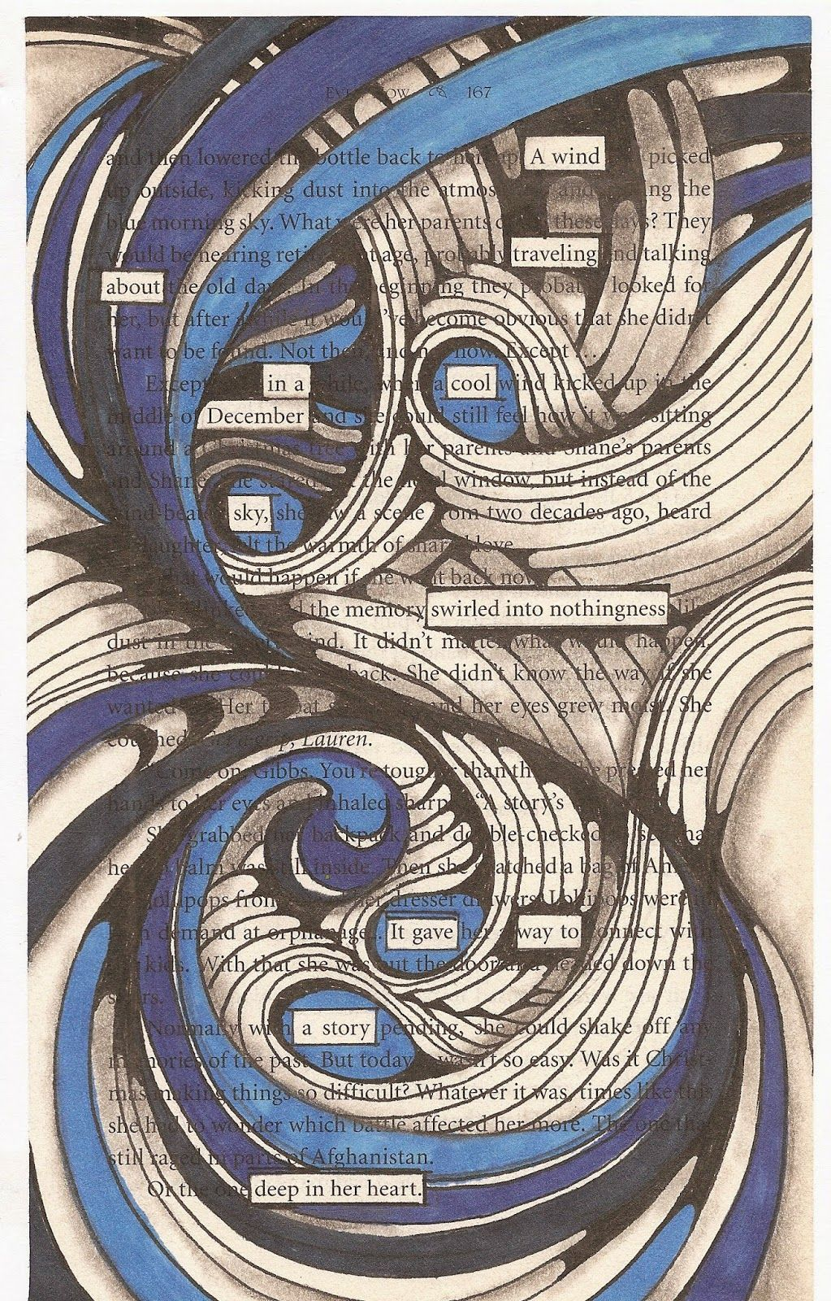
https://i.pinimg.com/originals/9e/a1/cc/9ea1cc4450068125489a4c54368822a6.jpg

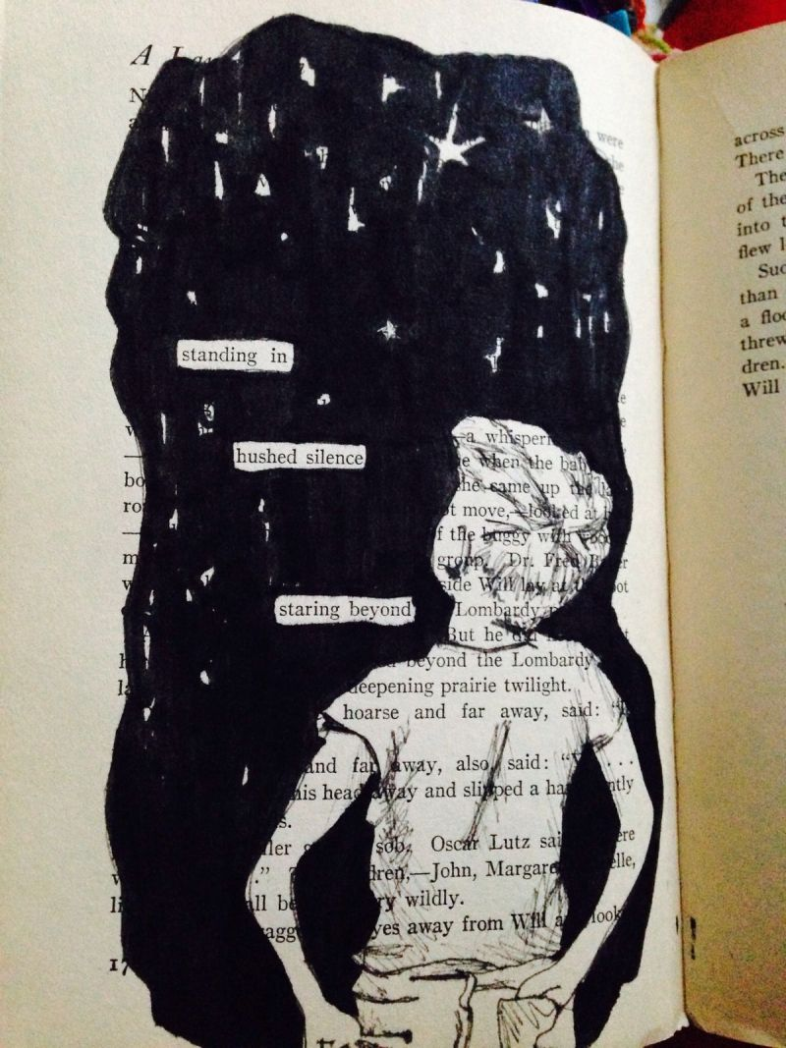

https://hvprice.files.wordpress.com/2012/10/wizard-of-earthsea-blackout-poetry1.jpg
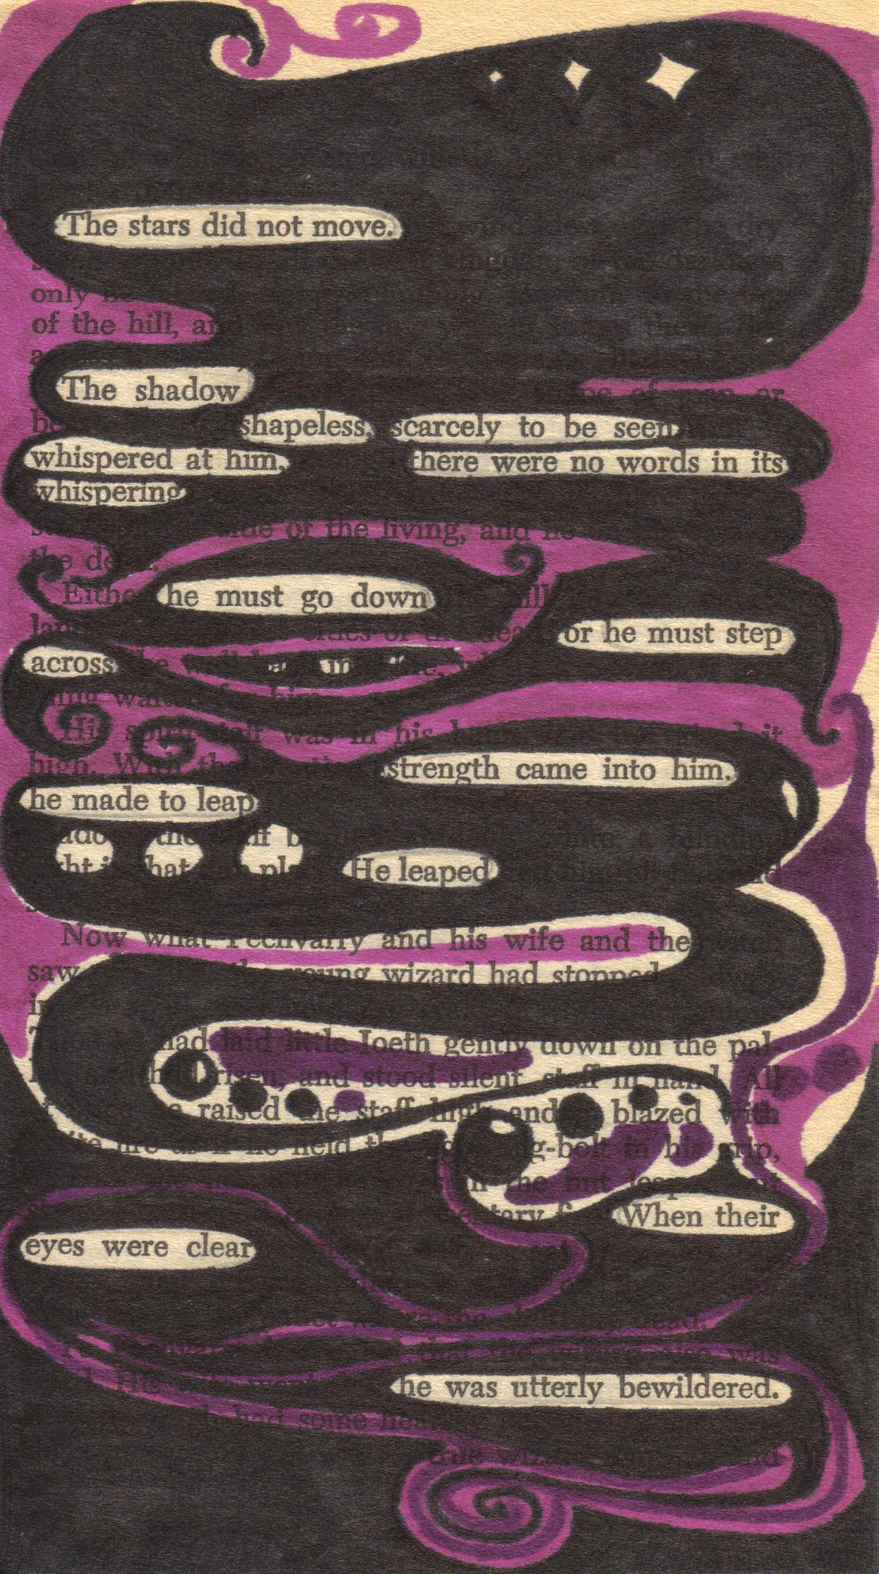

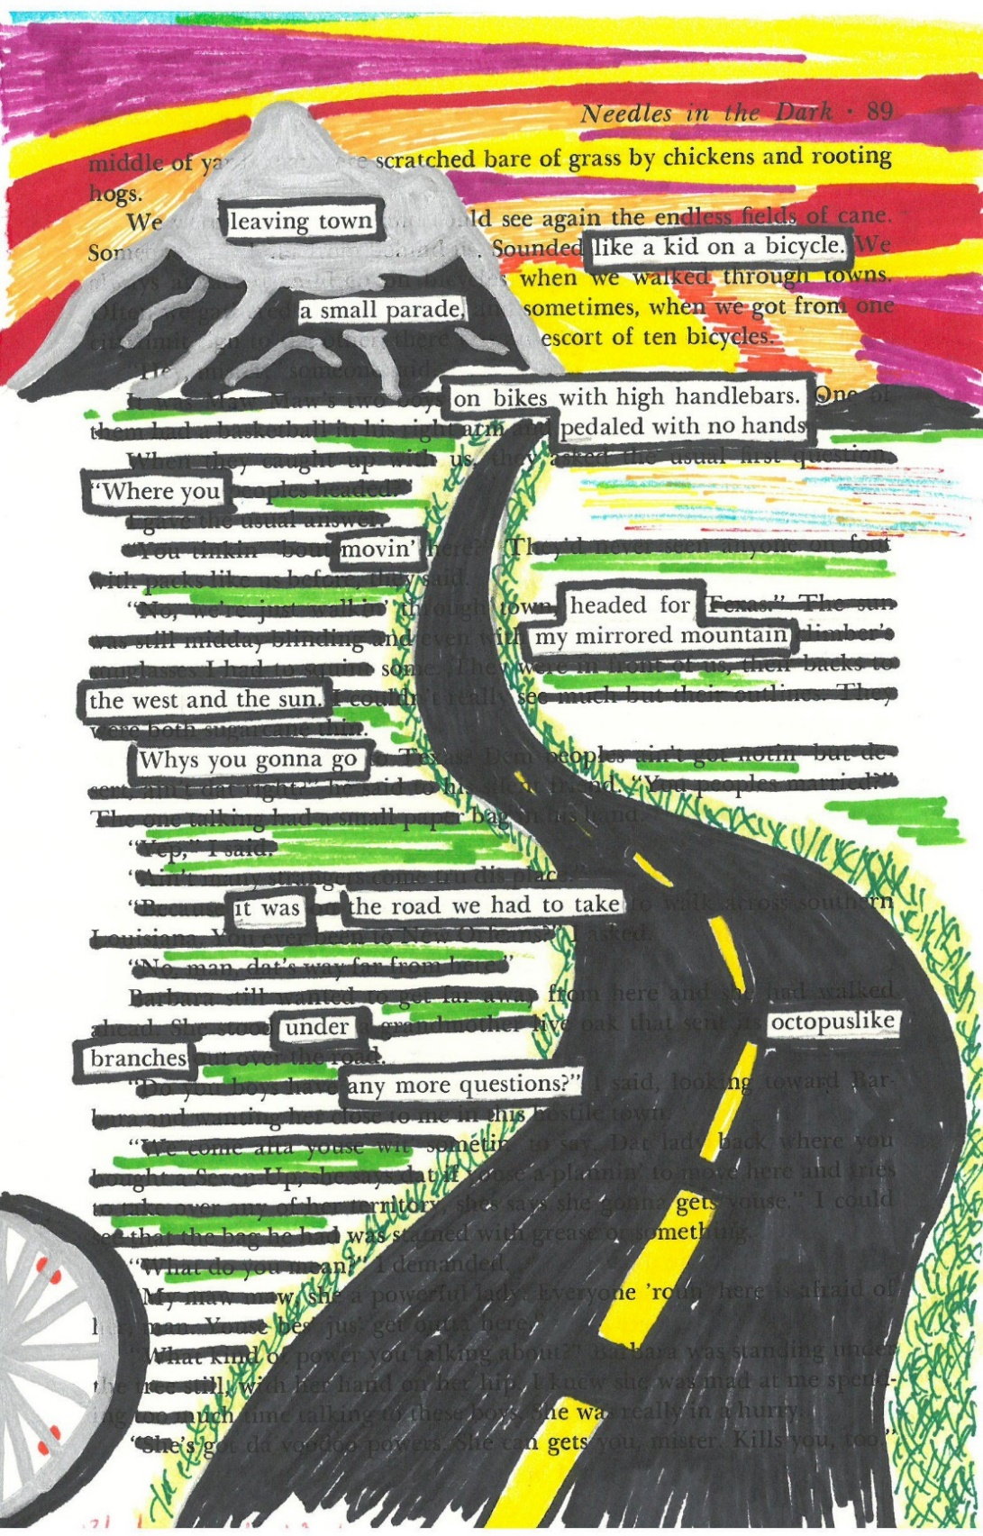https://tararualibrary.files.wordpress.com/2018/06/blackout-poetry-coloured.jpg Source

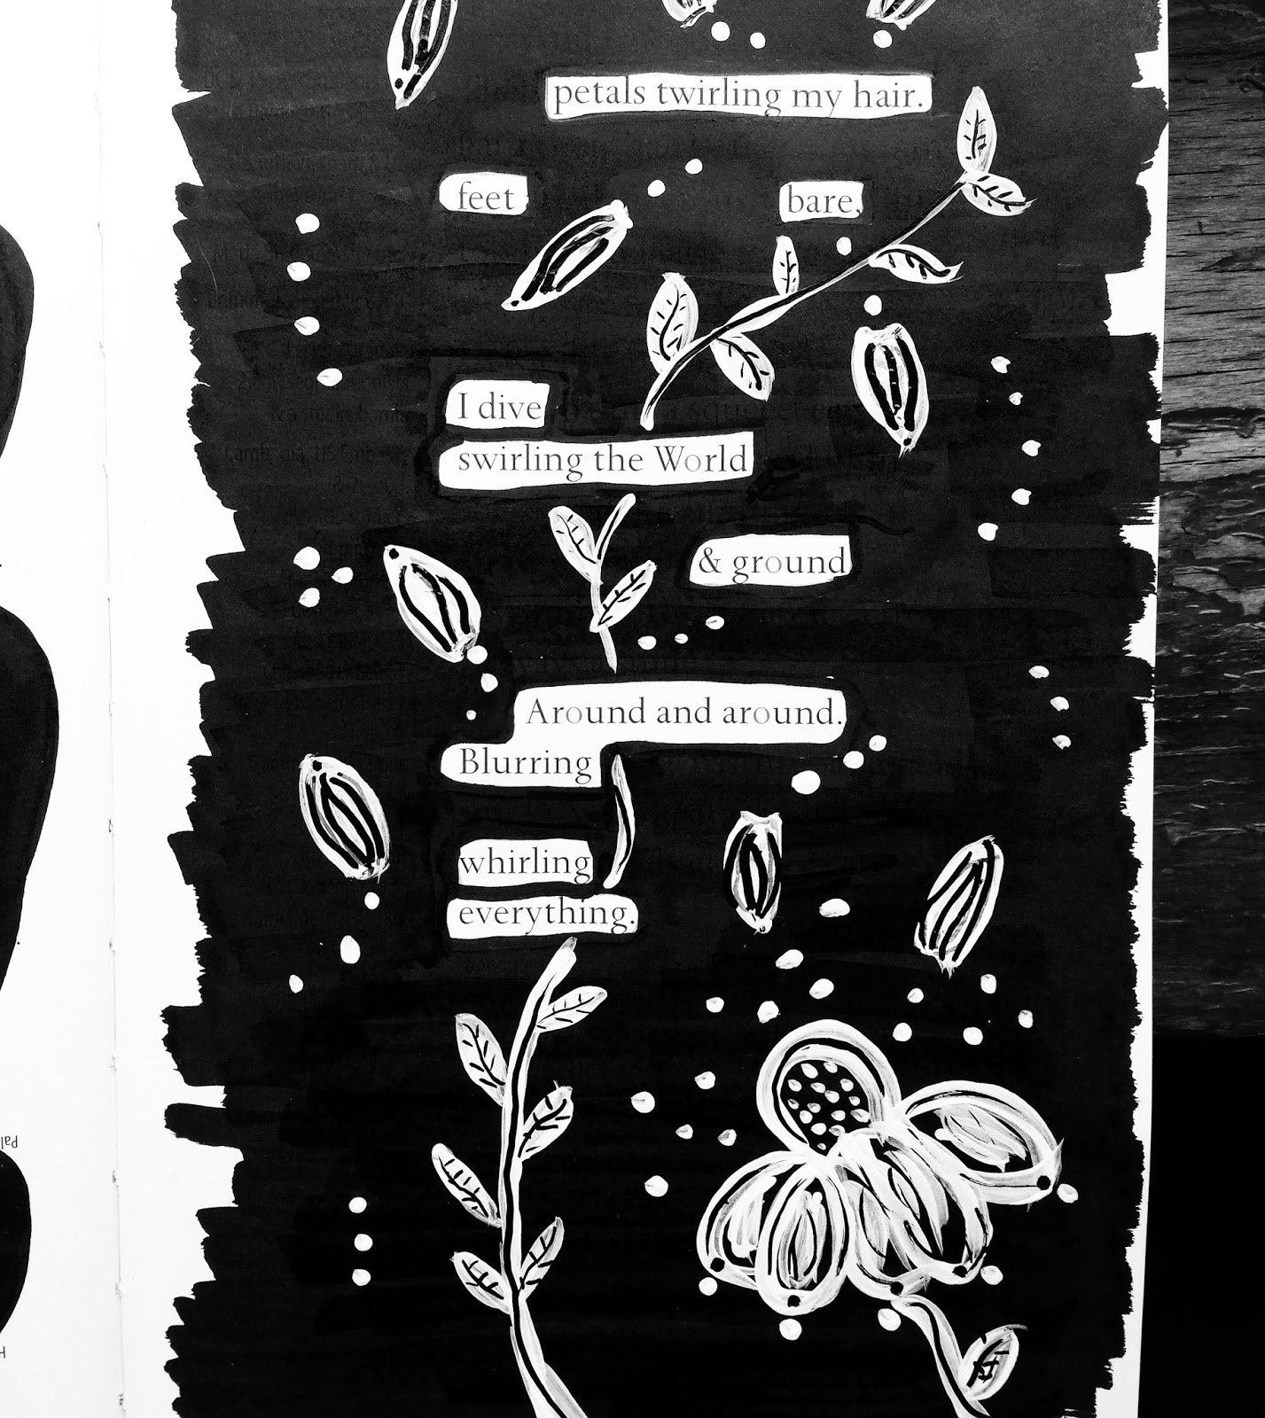
https://3.bp.blogspot.com/-lkhKjF4zHwU/WMXbmmBv0jI/AAAAAAAAzsk/0avLWsFaJwUDyyiEfNnS0WA4JMkUw9yuACLcB/s1600/IMG_20170312_175004_980.jpg

