WEEK: APRIL 13th-17th (K-4 Calendar)

MONDAY  APRIL 13th | AM ACTIVITY: Maps, Maps, and Maps!!  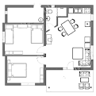  INSTRUCTIONS: Draw a map of your bedroom  K-4  - Draw a detailed map of your bedroom  - Label all items you have drawn in your bedroom  - Ask a parent or sibling to help you measure the distance between the furniture in your bedroom using “non-standard units of measure”  “Nonstandard units of measurement are units of measurement that aren't typically used, such as a pencil, an arm, a toothpick, or a shoe” | PM ACTIVITY: Indoor Scavenger Hunt  INDOOR SCAVENGER HUNT FOUND IT!  Find a fork  Find something that is red  Find a tissue box  Find 3 things that have wheels  Find an orange crayon  Find something that is very soft  Find a band-aid  Find a key  Find 2 socks that match  Find something round  Find a sticker  Find a rubber band  Find a pair of glasses  Find an envelope  INSTRUCTIONS: Indoor Scavenger Hunt  - Please use the list provided to have a scavenger hunt throughout the house.  - Can you find all the items?  - What items are you missing?  - Can you think of any other items to add to the list?

WEEK: APRIL 13th-17th (K-4 Schedule)

Tuesday April 14th | AM ACTIVITY: The Plane, The Plane!  INSTRUCTIONS: Paper Airplanes  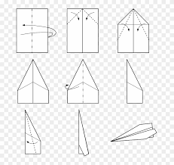  - Make a paper airplane out of any material that you may feel would work the best. (Ask a parent or sibling for help if you need it)  - Have a contest to see whose airplane flies the furthest  - Measure the distant of how far each airplane has travelled using non-standard” units of measure  “Nonstandard units of measurement are units of measurement that aren't typically used, such as a pencil, an arm, a toothpick, or a shoe” | PM ACTIVITY: SHAPES SCAVENGER HUNT  SHAPES SCAVENGER HUNT FOUND IT!  find something that turns that is a circle  Find something in the kitchen that is a square  Find 4 things that are rectangles  Find something in the shape of a heart  Find something in your room that is a rectangle  Find something that is a cylinder that is in the kitchen  Find something that is the shape of a triangle  Find something that is shaped like a cube  Find 3 things that are circles  INSTRUCTIONS: SHAPES SCAVENGER HUNT  - Please use the list provided to have a scavenger hunt throughout the house.  - Can you find all the items?  - What items are you missing?  - Can you think of any other items to add to the list?  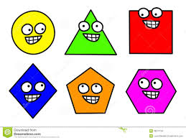

WEEK: APRIL 13th-17th (K-4 Schedule)

Wednesday April 15th | AM ACTIVITY: Do you hear what I hear?  INSTRUCTIONS: Listen and talk  - Listen to a song - any song!  - Answer these questions.  - Tell a family member your answers.  - Is the music high or low?  - Is the music fast or slow?  - Is the music loud or quiet?  - Can you name some instruments you hear?  - How does the music make you feel? | PM ACTIVITY: RHYMING SCAVENGER HUNT  RHYMING SCAVENGER HUNT FOUND IT!  Find something that rhymes with bee  Find something that rhymes with moon  Find something that rhymes with bear  Find something that rhymes with rock  Find something that rhymes with hose  Find something that rhymes with sub  Find something that rhymes with bug  Find something that rhymes with car  Find something that rhymes with fan  INSTRUCTIONS:  - Please use the list provided to have a scavenger hunt throughout the house.  - Can you find all the items?  - What items are you missing?  - Can you think of any other items to add to the list?  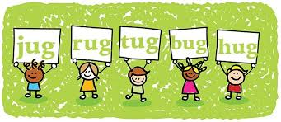

WEEK: APRIL 13th-17th (K-4 Schedule)

Thursday April 16th | AM ACTIVITY: THINK OUT OF THE BOX THURSDAY  INSTRUCTIONS:  - Complete the following three drawings  (it’s not a wave)  (It’s not a cloud)  (it’s not a moon) | PM ACTIVITY: Black and White SCAVENGER HUNT  BLACK AND WHITE SCAVENGER HUNT FOUND IT!  Find something soft that is white  Find something that moves that is black  Find something you can eat that is white  Find 2 things that match that are black  Find something rectangular that is white  Find something that is white that is in your room  Name an animal that is black  Name something outside that is white  Name an animal that is black and white  INSTRUCTIONS: Black and White SCAVENGER HUNT  - Please use the list provided to have a scavenger hunt throughout the house.  - Can you find all the items?  - What items are you missing?  - Can you think of any other items to add to the list?

WEEK: APRIL 13th-17th (K-4 Schedule)
Friday April 18th | AM ACTIVITY: LISTEN AND DRAW  INSTRUCTIONS: Listen to a song and draw  - Choose a song - any song!  - Draw a picture of what you imagine while you are listening using your five senses.  - What do you smell while listening to the song?  - What do you hear while listening to the song?  - What do you taste while listening to the song?  - What do you see while listening to the song?  - How do you feel while listening to the song? | PM ACTIVITY: Rainbow SCAVENGER HUNT  Rainbow Scavenger Hunt FOUND IT!  Find something red  Find something yellow  Find something orange  Find something green  Find something purple  Name a fruit that is red  Name an animal that is yellow  Name a vegetable that is orange  Name a plant that is green  Name a flower that is purple  Name something outside that is blue  INSTRUCTIONS: Rainbow SCAVENGER HUNT  - Please use the list provided to have a scavenger hunt throughout the house.  - Can you find all the items?  - What items are you missing?  - Can you think of any other items to add to the list?

